Project 6: Manual Strategy

GTID Student Name: Zhiyong Zhang
GT User ID: zzhang726
GT ID: 903370141

Part 1: Technical Indicators

Three Technical indicators were developed and described bellow.

1. Bollinger Bands

Bollinger Bands consist of a middle band (which is a simple moving average, SMA) and an upper and lower band. These upper and lower bands are set above and below the moving average by a certain number of standard deviations of price, thus incorporating volatility. The general principle is that by comparing a stock’s position relative to the bands, a trader may be able to determine if a stock’s price is relatively low or relatively high. The width of the band can be an indicator of its volatility (narrower bands indicate less volatility while wider ones indicate higher volatility).

The Bollinger Band indictors is defined as
bb_value[t] = (price[t] - SMA[t])/(2 * stdev[t])
where, price[t] is stock price, SMA[t] is simple moving average stock price, and stdev[t] is the standard deviation of stock price.

The price corresponding to bb_value of 1 is the upper band, which is a selling signal. While the price corresponding to bb_value of -1 is the lower band, which is a buying signal.

Figures 1 illustrates stock price, SMA, upper Bollinger Band, lower Bollinger Band, and selling and buying signals.
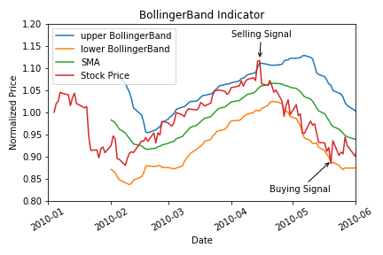
Figure 1: Bollinger Band Indicator

2. Price/SMA indicator

Price/SMA is the ratio of stock price over simple moving average of stock price (SMA). SMA is a good indicator for the actual value of the stock. The ratio Price/SMA evaluates how far the price may have deviated from actual value. High value of Price/SMA , such as 1.05, indicates the price is over estimated, which is a selling signal. While low value of Price/SMA, , such as 0.95, indicates the price is under estimated, which is a buying signal.

Figures 2 illustrate stock price, SMA, over estimated Price/SMA, under estimated Price/SMA, and selling and buying signals.

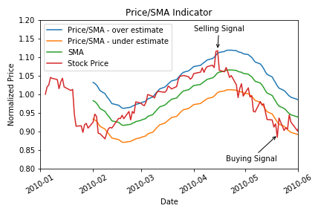

Figure 2: Price/SMA Indicator

3. Exponential Moving Averages (EMA)

The exponential moving average (EMA) focuses more on recent prices than on a long series of data points, it is calculated as

Current EMA = ((Price(current) - previous EMA) X multiplier) + previous EMA.

The most important multiplier factor is the smoothing constant that = 2/(1+N) where N = the number of days.

And Initial EMA is calculated as: N-period sum / N ( same to SMA)

The calculation makes the EMA quicker to react to price changes, causing a trader to get out of a trade on a market hiccup, resulting in a bigger profit after the hiccup is finished. However, the faster moving EMA signals trouble quicker than the SMA, and so the EMA trader gets out of harm's way quicker, saving that person time and money.

High value of Price/EMA, such as 1.05, indicates the price is over estimated, which is a selling signal. While low value of Price/SMA, such as 0.95, indicates the price is under estimated, which is a buying signal.

Figures 3 illustrate stock price, EMA, over estimated Price/EMA, under estimated Price/EMA, and selling and buying signals.

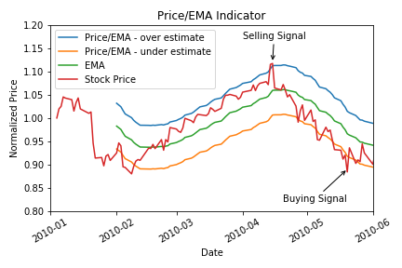
Figure 3: Price/EMA Indicator

Part 2: Theoretically Optimal Strategy

In this strategy, We assume that we can see the future and know the stock price trend. We will long stock if we know stock will go up on the next trading day and short stock if we know stock will go down on the next trading day. However, we are are constrained by the portfolio size and order limits are 1000 shares long, 1000 shares short and 0 shares.

A set of trades that represents the best a strategy could possibly do during the in sample period are created. The reason to do this is that we want to have an idea of an upper bound on performance. And indicator ( stock_price.diff(-1) ) showing the stock price difference from current trading day to next trading is used as buying and selling indicator.

For this activity, $0.00, and 0.0 for commissions and impact are used respectively.

The performance of a portfolio starting with $100,000 cash, investing in 1000 shares of JPM and holding that position is used as benchmark. Both benchmark and theoretically optimal portfolio are normalized to 1.0 at the start. The performance are plotted in Figure 4. The Green line shows the result of benchmark and Red line shows the result of theoretically optimal portfolio. The Performance summary of benchmark and theoretically optimal portfolio are showed in Table 1.

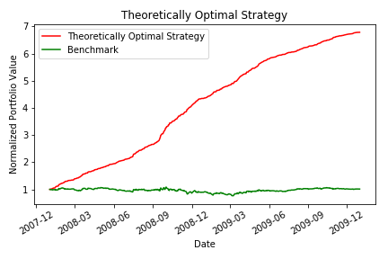
Figure 4. Performance of benchmark and theoretically optimal portfolio.

 | Cumulative return | Standard Deviation of daily returns | Mean of daily returns
Benchmark | 1.0123 | 0.017 | 0.00017
Optimal portfolio | 6.7861 | 0.0045 | 0.0038

Table 1. The performance summary of benchmark and theoretically optimal portfolio.

Part 3: Manual Rule-Based Trader

A set of rules using the Bollinger Bands indicators are implemented. If bb_value indicator is less than -1, enter position of the stock is recorded. If bb_value indicator is larger than 1, exit position of the stock is recorded. If bb_value indicator is between -1 and 1, do nothing will be recorded.

Logical expressions that yields a -1, 0, or 1, corresponding to a "short," "out" or "long" position were created. After that, a trade order dataframe will be generated. If we are out of the stock, then a 1 would signal a BUY 1000 order. If were are long, a -1 would signal a SELL 2000 order.

The days of rolling window are tweaked to get the best returns. It is found that a 10 days windows would yield the best performance possible during the in sample period

After a trades dataframe is generated over the in sample period using rule-based strategy, the market simulator is run to created portfolio. Then charts and performance indicators were reported.

For this activity, commission of $9.95 and impact of 0.005 are used respectively.

The performance of a portfolio starting with $100,000 cash, investing in 1000 shares of JPM and holding that position is used as benchmark. Both benchmark and manual strategy portfolio are normalized to 1.0 at the start. The performance are plotted in Figure 5. The Green line shows the result of benchmark and Red line shows the result of manual strategy portfolio. Vertical blue lines indicates LONG entry points and vertical black lines indicating SHORT entry points. The Performance summary of benchmark and manual strategy are showed in Table 2. The Bollinger Bands with SMA and stock price for stock JPM are plotted on Figure 6.

The results show Bollinger Band is an effective strategy as stock price has tendency to move back to its actual value and SMA is a good indicator of actual stock values.
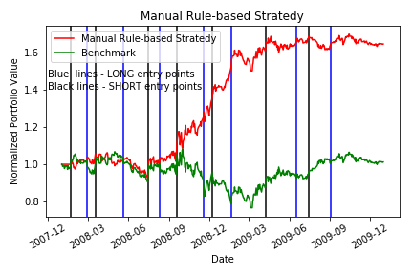
Figure 5. Performance of benchmark and manual rule-based portfolio.

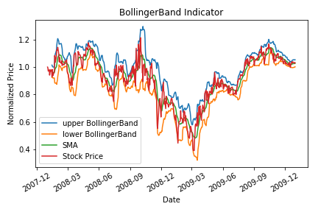
Figure 6. Bollinger Band indicator with SMA and stock price for stock JPM.

 | Cumulative return | Standard Deviation of daily returns | Mean of daily returns
Benchmark | 1.012 | 0.0170 | 0.00017
Manual rule-based | 1.648 | 0.0127 | 0.00107

Table 2. The performance summary of benchmark and manual rule-based portfolio.

Part 4: Comparative Analysis
The performance of your strategy in the out of sample period are evaluated. The Bollinger Band strategy with window of 10 days learned using the in sample data are used. Figure 7 shows the performance of out sample period for manual strategy and Benchmark. Both of them are normalized to 1.0 at the start.
Table 3 summarizes the performance of the stock, and the manual strategy for both in sample and out of sample periods.
The main reason of the performance difference between out sample and in sample periods are: the parameters for manual rule based strategy, such as rolling band window, are tweaked for in sample period only and it may not perform best for out sample period. However, the portfolio using manual rule based strategy are performed better than Benchmark of both of the periods.
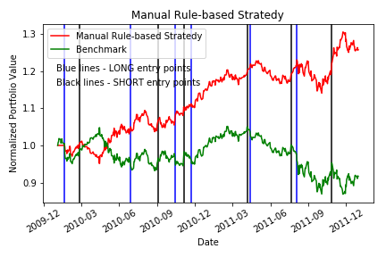
Figure 7. Performance of benchmark and manual rule-based portfolio.

 | Cumulative return | Standard Deviation of daily returns | Mean of daily returns
In sample Benchmark | 1.012 | 0.0170 | 0.00017
In sample Manual rule-based | 1.648 | 0.0127 | 0.00107
Out sample Benchmark | 0.916 | 0.0085 | -0.00013
Out sample Manual rule-based | 1.258 | 0.0069 | 0.00048

Table 3. The performance summary of benchmark and manual rule-based portfolio for in sample and out sample periods.

